4.6 DESIGN OF BEAMS:
4.6.1 BEAM:
Beam is a horizontal structural member which transmits loads horizontally along their length to the supports where the loads are generally transformed into vertical forces. The objective of Beams is to withstand vertical loads, shear forces and bending moments.
Depending on the types of supports the beams are classified as:
- Simply supported beam
- Cantilever beam
- Over hanging beam
- Continuous beam
- Fixed beam
- Propped cantilever beam
Code limitations:
In IS-456-2000-page No.48, the limitations and specifications for beam design are given as
Beams:
Tension reinforcement:
a) Minimum reinforcement -The minimum area of tension reinforcement shall be not less than that given by the following:
$$\frac{A_{s}}{bd}= \frac{0.87}{f_{y}}$$
Where,
A_{s}= minimum area of tension reinforcement,
b = breadth of beam or the breadth of the web of T-beam.
d = effective depth, and
f_{y} = characteristic strength of reinforcement in N/mm2
b) Maximum reinforcement – The maximum area of tension reinforcement shall not exceed 0.04bD.
Compression reinforcement:
The maximum area of compression reinforcement shall not exceed 0.04bD. Compression reinforcement in beams shall be enclosed by stirrups for effective lateral restraint.

Side face reinforcement:
Where the depth of the web in a beam exceeds 750mm, side face reinforcement shall be provided along the two faces. The total area of such reinforcement shall be not less than 0.1 percent of the web area and shall be distributed equally on two faces at a spacing not exceeding 300mm or web thickness whichever is less.
Transverse reinforcement in beams for shear and torsion:
The transverse reinforcement in beams shall be taken around the outer-most tension and compression bars. "In T-beams and I-beams, such reinforcement shall pass around longitudinal bars located close to the outer face of the flange
Maximum spacing of shear reinforcement:
The maximum spacing of shear reinforcement measured along the axis of the member shall not exceed 0.75d for vertical stirrups and d for inclined stirrups at 45º, where d is the effective depth of the section under consideration. In no case shall the spacing exceed 300mm.
Minimum shear reinforcement:
Minimum shear reinforcement in the form of stirrups shall be provided such that:
$$\frac{A_{sv}}{bS_{v}} ≥ \frac{0.4}{0.87f_{y}}$$
Where,
A_{sv} = total cross-sectional area of stirrup legs effective in shear.
S_{v} = stirrup Spacing along the Length of the member.
b = breadth of the beam or breadth of the web of flanged beam.
f_{y} = characteristic strength of the stirrup reinforcement in N/mm2 which shall not be taken greater than 415N/mm².
Where the maximum shear stress calculated is less than half the permissible value and in members of minor structural importance such as lintels. This provision need not be complied with.
Minimum reinforcement:
The mild steel reinforcement in either direction in slab shall not be less than 0.15percent of the total cross-sectional area. However, this value can be reduced to 0.12 percent when high strength deformed bars or welded wire fabric are used.

4.6.2 DESIGN OF CONTINUOUS BEAM IN FRAME A1-B1-C1:
ASSUMPTIONS:

Size of the beam
= 230X400mm
Effective cover = 30 mm
Grade of the concrete =M₂₀
Grade of the steel = Fe 500
f_{ck} = 20 N/m²
f_{y} = 500 N/m²

Effective depth (d)
= D - Effective cover
d = 400-30 = 370mm
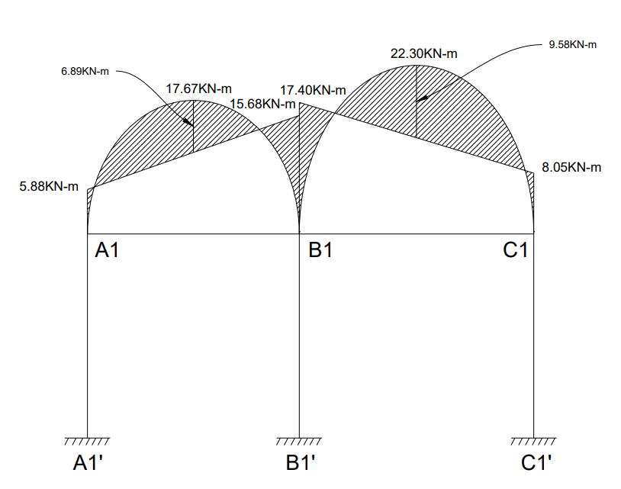
Figure 4.5: Bending moment diagram {frame A1-B1-C1}

Code limits:
As per code if Mu is less than M_{u,limit} then the section is design as a singly reinforced section otherwise it should be design as doubly reinforced section.
$$M_{u,limit} = 0.36 \frac{x_{u max}}{d} (1 - 0.42 \frac{x_{u max}}{d}) bd^{2}f_{ck}$$
$$M_{u,limit} = 0.36 \frac{0.46d}{d} (1 - 0.42 \frac{0.46d}{d} ) 230×{370}^{2} ×20$$
$$M_{u,limit} = 84.14 kN-m$$
The minimum and maximum area of steel in beam is given below [ It is given in page No.46of IS - 456-2000 in article 26.5.1.1.]
$$A_{st (minimum)}=\frac{0.85}{f_{y}} bd$$
$=\frac{0.85}{500} ×230×370=144.67{ mm}^{2}$
$$A_{st (maximum)}=0.04bD$$
$=0.04×230×400=3680 {mm}^{2}$
4.6.2.1 AREA OF THE REINFORCEMENT REQUIRED:
Let us consider BEAM A1-B1-C1:
Tension steel in span A1-B1:
$$M=6.89 kN-m$$
$$M_{u}=1.5×6.89 =10.34 kN-m$$
DEPTH REQUIRED:
M_{u} =M_{u,limit}
$$M_{u} = 0.36 \frac{x_{u max}}{d} (1 - 0.42 \frac{x_{u max}}{d}) bd^{2}f_{ck}$$
For 500 grade steel, $x_{u max}$ = 0.46d which is given in page No.70 of IS - 456-2000 in article38.1.] Here bending moment is used to check the thickness.
$$10.34×{10}^{6} = 0.36 \frac{0.46d}{d} (1 - 0.42 \frac{0.46d}{d} ) 230×d^{2} ×20$$
$d_{(required)}$ = 130 mm
$d_{(required)}$<$d_{(provided)}$
So, the section is safe in bending.
M_{u} < M_{u,limit}
So, the section is designed as singly reinforced beam.
$$M_{u}= 0.87 f_{y}A_{st} d (1- \frac{f_{y}A_{st}}{bd f_{ck}})$$
$$10.34×{10}^{6}= 0.87 × 500× A_{st}×370 (1- \frac{500×A_{st}}{230×370× 20})$$
$$A_{st}=65.50{ mm}^{2}$$
$$A_{st(required)}<A_{st (minimum)}$$
So, provide minimum $A_{st}$
Provide 2 bars of #10mm$∅$ bars {$A_{st(provided)}=157.08 {mm}^{2}$}
Tension steel in span B1-C1:
$$M=9.58 kN-m$$
$M_{u}=1.5×9.58 =14.37 kN-m$< M_{u,limit}
So, the section is designed as singly reinforced beam.
$$M_{u}= 0.87 f_{y}A_{st} d (1- \frac{f_{y}A_{st}}{bd f_{ck}})$$
$$14.37×{10}^{6}= 0.87 × 500× A_{st}×370 (1- \frac{500×A_{st}}{230×370× 20})$$
$$A_{st}=91.76{ mm}^{2}$$
$$A_{st(required)}<A_{st (minimum)}$$
So, provide minimum $A_{st}$
Provide 2 bars of #10mm$∅$ bars {$A_{st(provided)}=157.08{mm}^{2}$}
Support steel at A1:
$$M=5.88kN-m$$
$M_{u}=1.5×5.88 =8.82 kN-m$ < M_{u,limit}
So, the section is designed as singly reinforced beam.
$$M_{u}= 0.87 f_{y}A_{st} d (1- \frac{f_{y}A_{st}}{bd f_{ck}})$$
$$8.82×{10}^{6}= 0.87 × 500× A_{st}×370 (1- \frac{500×A_{st}}{230×370× 20})$$
$$A_{st}=57.74{ mm}^{2}$$
𝐴𝑠𝑡(𝑟𝑒𝑞𝑢𝑖𝑟𝑒𝑑) < 𝐴𝑠𝑡 (𝑚𝑖𝑛𝑖𝑚𝑢𝑚)
Provide 2 bar of #10mm$∅$ bar {$A_{st(provided)}=157.08 {mm}^{2}$}
Support steel at B1:
$$M=17.40 kN-m$$
$M_{u}=1.5×17.40 =26.1 kN-m<$ M_{u,limit}
So, the section is designed as singly reinforced beam.
$$M_{u}= 0.87 f_{y}A_{st} d (1- \frac{f_{y}A_{st}}{bd f_{ck}})$$
$$26.1×{10}^{6}= 0.87 × 500× A_{st}×370 (1- \frac{500×A_{st}}{230×370× 20})$$
$$A_{st}=170.72{ mm}^{2}$$
Provide 2 bar of #12mm$∅$ bar {$A_{st(provided)}=226.20 {mm}^{2}$}

Support steel at C1:
$$M=8.05 kN-m$$
$M_{u}=1.5×8.05 =12.08 kN-m$< M_{u,limit}
So, the section is designed as singly reinforced beam.
$$M_{u}= 0.87 f_{y}A_{st} d (1- \frac{f_{y}A_{st}}{bd f_{ck}})$$
$$12.08×{10}^{6}= 0.87 × 500× A_{st}×370 (1- \frac{500×A_{st}}{230×370× 20})$$
$$A_{st}=76.78{ mm}^{2}$$
$$A_{st(required)}<A_{st (minimum)}$$
So, provide minimum $A_{st}$
Provide 2 bars of #10mm$∅$ bars {$A_{st(provided)}=157.08{mm}^{2}$}
4.6.2.2 Check for deflection:
For span A1-B1:
$$d_{req}= \frac{L}{BV ×MF}$$
L = 2.8 m
The BV Value for Continuous Beam (IS – 456 – 2000, page no. 37)
BV = 26
$$P_{t}= \frac{A_{st}}{bd} ×100=\frac{157.08}{230 ×370} ×100= 0.18$$
From IS – 456 – 2000, page no. 38
$$f_{s}=0.58 ×f_{y} × \frac{Area of cross-section of steel required}{Area of cross-section of steel provided}$$

$$f_{s}=0.58 ×500 × \frac{65.50}{157.08}=120.92 N/{mm}^{2}$$
From the graph, in IS – 456 – 2000, page no. 38
MF = 2
$$d_{req}= \frac{2800}{26 ×2}=53.84<d_{prov}=370mm$$
For span B1-C1:
$$d_{req}= \frac{L}{BV ×MF}$$
L = 3.1 m
The BV Value for Continuous Beam (IS – 456 – 2000, page no. 37)
BV = 26
$$P_{t}= \frac{A_{st}}{bd} ×100=\frac{157.08}{230 ×370} ×100= 0.18$$
From IS – 456 – 2000, page no. 38
$$f_{s}=0.58 ×f_{y} × \frac{Area of cross-section of steel required}{Area of cross-section of steel provided}$$
$$f_{s}=0.58 ×500 × \frac{91.76}{157.08}=169.40 N/{mm}^{2}$$
From the graph, in IS – 456 – 2000, page no. 38
MF = 2
$$d_{req}= \frac{3100}{26 ×2}=59.61<d_{prov}=370mm$$
4.6.2.3 Design of shear reinforcement in Slab beams:
Span A1-B1:
Joint A1:
V = 21.74 KN
V_{u} = 32.61 KN
The nominal shear stress in beam of uniform depth shall be obtained by the following equation.
$τ_{v}=\frac{V_{u}}{bd}$
$=\frac{32.61 ×1000}{230×370}=0.38 N/{mm}^{2}$
$$P_{t}=\frac{A_{st}}{bd}×100$$
$$=\frac{157.08}{230×370}×100=0.18\%$$

Under no circumstances, for shear reinforcement, the nominal shear stress in beam $τ_{v}$ shall not exceed $τ_{c,max}$. [ It is given in page No.73 of IS - 456-2000 in Table No.20]
$τ_{c,max}$= 2.8 N/mm²
$τ_{v}$<$τ_{c,max}$
$τ_{c}$Value is given in page 73 of is 456: 2000. This value is depending on $P_{t}$ value and grade of concrete. For our condition M₂₀ grade and $P_{t}=0.18$ the value is given below
$$τ_{c}=0.30 N/{mm}^{2}$$
$$τ_{v}>τ_{c}$$
As per IS 456 : 2000, when the $τ_{v}$ exeed $τ_{c}$ value the shear reinforcement shall be provided.[ It is given in page No.72of IS - 456-2000 in article 40.4.]
$V_{us}=V_{u}-τ_{c}$bd
= 32.61 x 10³ – 0.3 x 230 x 370 = 7.08 KN
Shear reinforcement shall be provided to carry a shear equal to $V_{u}-τ_{c}$ bd. The strength of the shear reinforcement $V_{us}$ for vertical stirrups is given below [IS 456 : 2000, p.no.73]
$$V_{us}=\frac{{0.87 { f}_{f}A}_{sv}d}{{ s}_{v}}$$
Using 8mm, 2 legged$F_{e}$500 steel stirrups, $A_{sv}=2 × \frac{π}{4}×8^{2}=100.53{mm}^{2}$
$$S_{v}=\frac{0.87×500×100.53×370}{7.08×1000}=2285.35 mm$$
Code limits:
[ It is given in page No.47of IS - 456-2000 in article 26.5.1.5.]
It should be lesser of the following
- $S=0.75d=0.75×370=277.5mm$
- $S=300mm$
So, provide 8 mm dia stirrups at 275 mm c/c
Span A1-B1:
Joint B1:
V = 28.74 KN
V_{u} = 43.11 KN

The nominal shear stress in beam of uniform depth shall be obtained by the following equation.
$τ_{v}=\frac{V_{u}}{bd}$
$=\frac{43.11 ×1000}{230×370}=0.51 N/{mm}^{2}$
$$P_{t}=\frac{A_{st}}{bd}×100$$
$$=\frac{226.20}{230×370}×100=0.27\%$$
Under no circumstances, for shear reinforcement, the nominal shear stress in beam $τ_{v}$ shall not exceed $τ_{c,max}$. [ It is given in page No.73 of IS - 456-2000 in Table No.20]
$τ_{c,max}$= 2.8 N/mm²
$τ_{v}$<$τ_{c,max}$
$τ_{c}$Value is given in page 73 of is 456: 2000. This value is depending on $P_{t}$ value and grade of concrete. For our condition M₂₀ grade and $P_{t}=0.27$ the value is given below
$$τ_{c}=0.37 N/{mm}^{2}$$
$$τ_{v}>τ_{c}$$
As per IS 456 : 2000, when the $τ_{v}$ exeed $τ_{c}$ value the shear reinforcement shall be provided.[ It is given in page No.72of IS - 456-2000 in article 40.4.]
$V_{us}=V_{u}-τ_{c}$bd
= 43.11 x 10³ – 0.37 x 230 x 370 = 11.62 KN
Shear reinforcement shall be provided to carry a shear equal to $V_{u}-τ_{c}$ bd. The strength of the shear reinforcement $V_{us}$ for vertical stirrups is given below [IS 456 : 2000, p.no.73]
$$V_{us}=\frac{{0.87 { f}_{f}A}_{sv}d}{{ s}_{v}}$$
Using 8mm, 2 legged $F_{e}$500 steel stirrups, $A_{sv}=2 × \frac{π}{4}×8^{2}=100.53{mm}^{2}$
$$S_{v}=\frac{0.87×500×100.53×370}{11.62×1000}=1392.45mm$$

Code limits:
[ It is given in page No.47of IS - 456-2000 in article 26.5.1.5.]
It should be lesser of the following
- $S=0.75d=0.75×370=277.5mm$
- $S=300mm$
So, provide 8 mm dia stirrups at 275 mm c/c
Span B1-C1:
Joint B1:
V = 31.79 KN
V_{u} = 47.69 KN
The nominal shear stress in beam of uniform depth shall be obtained by the following equation.
$τ_{v}=\frac{V_{u}}{bd}$
$=\frac{47.69 ×1000}{230×370}=0.56 N/{mm}^{2}$
$$P_{t}=\frac{A_{st}}{bd}×100$$
$$=\frac{226.20}{230×370}×100=0.27\%$$
Under no circumstances, for shear reinforcement, the nominal shear stress in beam $τ_{v}$ shall not exceed $τ_{c,max}$. [ It is given in page No.73 of IS - 456-2000 in Table No.20]
$τ_{c,max}$= 2.8 N/mm²
$τ_{v}$<$τ_{c,max}$
$τ_{c}$Value is given in page 73 of is 456: 2000. This value is depending on $P_{t}$ value and grade of concrete. For our condition M₂₀ grade and $P_{t}=0.27$ the value is given below
$$τ_{c}=0.37 N/{mm}^{2}$$
$$τ_{v}>τ_{c}$$
As per IS 456 : 2000, when the $τ_{v}$ exeed $τ_{c}$ value the shear reinforcement shall be provided.[ It is given in page No.72of IS - 456-2000 in article 40.4.]
$V_{us}=V_{u}-τ_{c}$bd
= 47.69 x 10³ – 0.37 x 230 x 370 = 16.20 KN
Shear reinforcement shall be provided to carry a shear equal to $V_{u}-τ_{c}$ bd. The strength of the shear reinforcement $V_{us}$ for vertical stirrups is given below [IS 456 : 2000, p.no.73]
$$V_{us}=\frac{{0.87 { f}_{f}A}_{sv}d}{{ s}_{v}}$$
Using 8mm, 2 legged $F_{e}$500 steel stirrups, $A_{sv}=2 × \frac{π}{4}×8^{2}=100.53{mm}^{2}$
$$S_{v}=\frac{0.87×500×100.53×370}{16.20×1000}=998.78mm$$
Code limits:
[ It is given in page No.47of IS - 456-2000 in article 26.5.1.5.]
It should be lesser of the following
- $S=0.75d=0.75×370=277.5mm$
- $S=300mm$
So, provide 8 mm dia stirrups at 275 mm c/c
Span B1-C1:
Joint C1:
V = 25.75 KN
V_{u} = 38.63 KN
The nominal shear stress in beam of uniform depth shall be obtained by the following equation.
$τ_{v}=\frac{V_{u}}{bd}$
$=\frac{38.63 ×1000}{230×370}=0.45 N/{mm}^{2}$
$$P_{t}=\frac{A_{st}}{bd}×100$$
$$=\frac{157.08}{230×370}×100=0.18\%$$
Under no circumstances, for shear reinforcement, the nominal shear stress in beam $τ_{v}$ shall not exceed $τ_{c,max}$. [ It is given in page No.73 of IS - 456-2000 in Table No.20]
$τ_{c,max}$= 2.8 N/mm²
$τ_{v}$<$τ_{c,max}$

$τ_{c}$Value is given in page 73 of is 456: 2000. This value is depending on $P_{t}$ value and grade of concrete. For our condition M₂₀ grade and $P_{t}=0.18$ the value is given below
$$τ_{c}=0.30 N/{mm}^{2}$$
$$τ_{v}>τ_{c}$$
As per IS 456 : 2000, when the $τ_{v}$ exeed $τ_{c}$ value the shear reinforcement shall be provided.[ It is given in page No.72of IS - 456-2000 in article 40.4.]
$V_{us}=V_{u}-τ_{c}$bd
= 38.63 x 10³ – 0.30 x 230 x 370 = 13.10 KN
Shear reinforcement shall be provided to carry a shear equal to $V_{u}-τ_{c}$ bd. The strength of the shear reinforcement $V_{us}$ for vertical stirrups is given below [IS 456 : 2000, p.no.73]
$$V_{us}=\frac{{0.87 { f}_{f}A}_{sv}d}{{ s}_{v}}$$
Using 8mm, 2 legged $F_{e}$500 steel stirrups, $A_{sv}=2 × \frac{π}{4}×8^{2}=100.53{mm}^{2}$
$$S_{v}=\frac{0.87×500×100.53×370}{13.10×1000}=1235.14 {mm}^{2}$$
Code limits:
[ It is given in page No.47of IS - 456-2000 in article 26.5.1.5.]
It should be lesser of the following
- $S=0.75d=0.75×370=277.5mm$
- $S=300mm$
So, provide 8 mm dia stirrups at 275 mm c/c
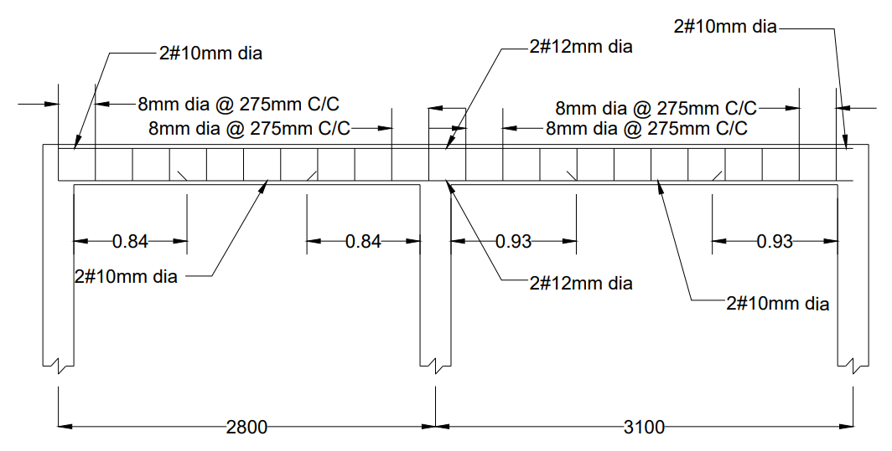
Figure 4.6: Reinforcement details of beam A1-B1-C1.

